Міністерство освіти і науки України
Карпатський національний університет
імені В.Стефаника

Факультет математики та інформатики
Кафедра інформаційних технологій

Інформатика і програмування

Лабораторна робота No 8

Тема: Manage Virtual Machines

Виконав: Прокутко В.В
Група ІПЗ-43
Дата: 14 грудня 2025
Викладач: Поварчук Д.Д

Івано-Франківськ – 2025

Task 1: Deploy zone-resilient Azure virtual machines by using the Azure portal

In this task, you will deploy two Azure virtual machines into different availability zones by using the Azure portal. Availability zones offer the highest level of uptime SLA for virtual machines at 99.99%. To achieve this SLA, you must deploy at least two virtual machines across different availability zones.

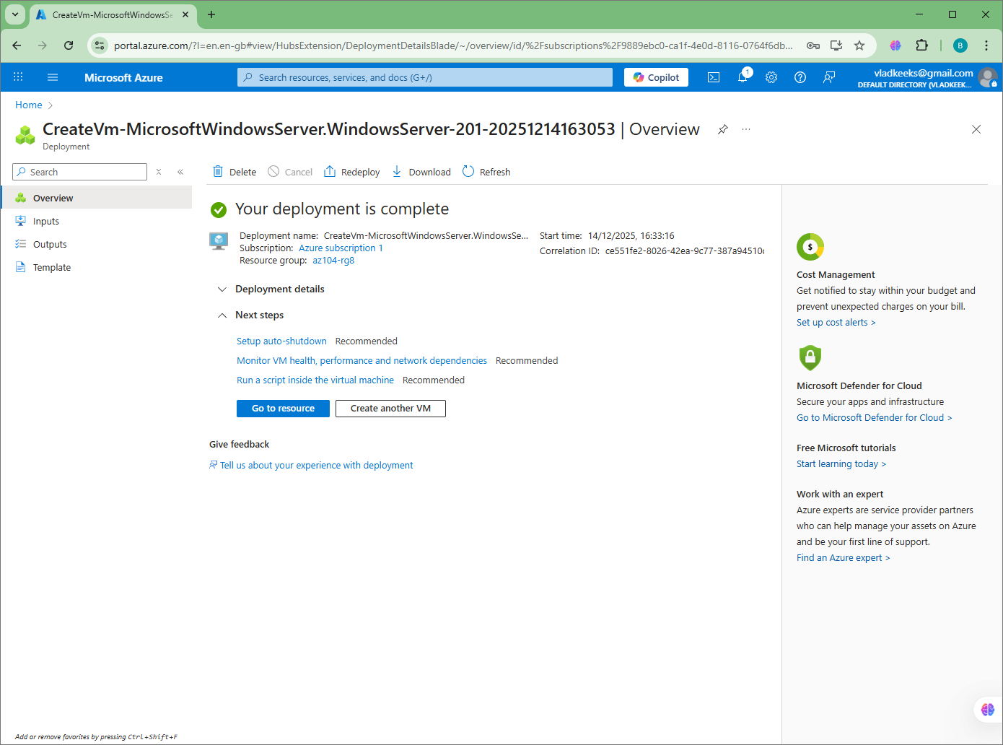

Task 2: Manage compute and storage scaling for virtual machines
In this task, you will scale a virtual machine by adjusting its size to a different SKU. Azure provides flexibility in VM size selection so that you can adjust a VM for periods of time if it needs more (or less) compute and memory allocated. This concept is extended to disks, where you can modify the performance of the disk, or increase the allocated capacity.

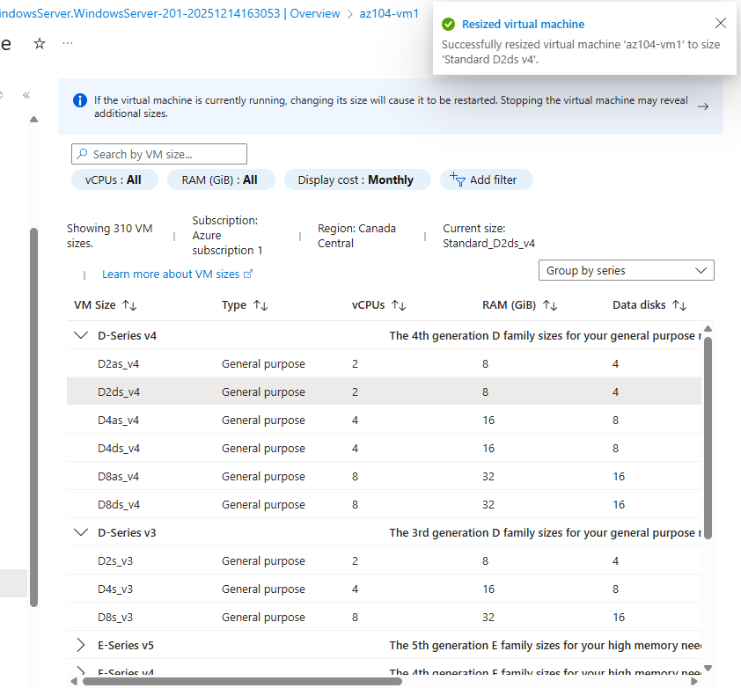

Under Data disks select + Create and attach a new disk. Configure the settings (leave other settings at their default values).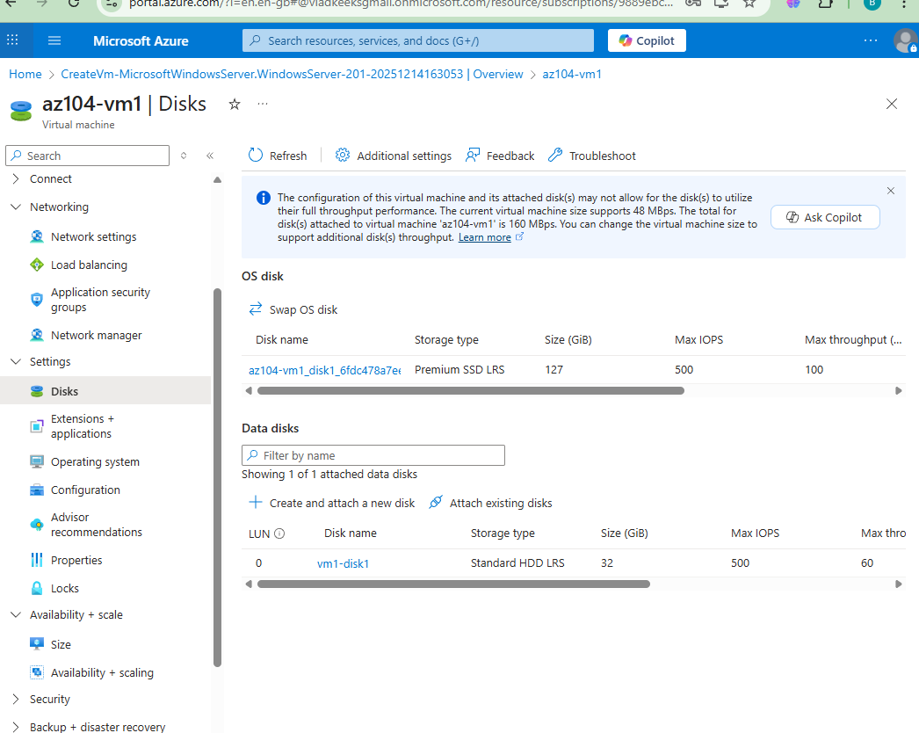

After the disk has been created, click Detach (if necessary, scroll to the right to view the detach icon), and then click Apply.
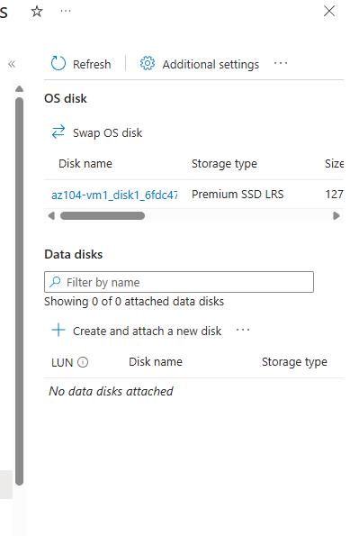

- Set the storage type to Standard SSD, and then click Save.

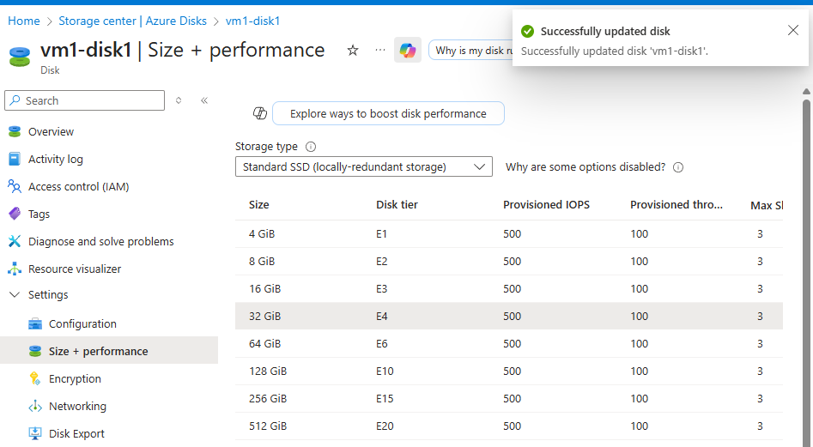
- In the Data disk section, select Attach existing disks.
- In the Disk name drop-down, select VM1-DISK1.
- Verify the disk is now Standard SSD.
- Select Apply to save your changes.
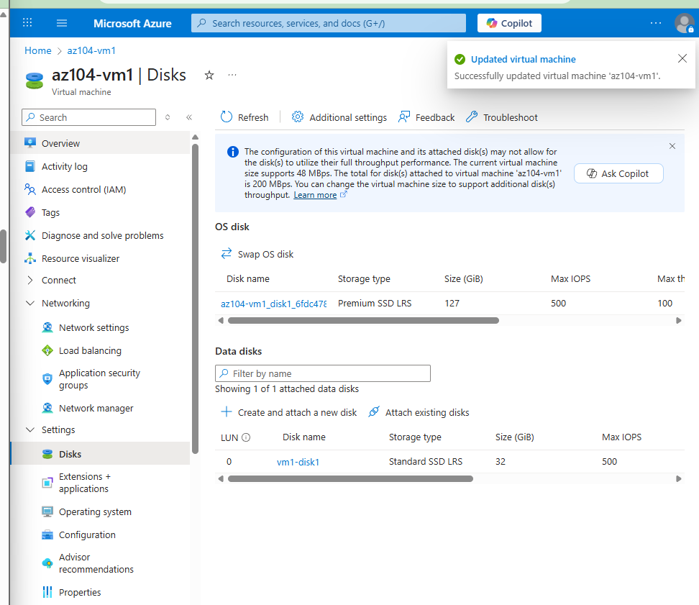

Task 3: Create and configure Azure Virtual Machine Scale Sets
In this task, you will deploy an Azure virtual machine scale set across availability zones. VM Scale Sets reduce the administrative overhead of automation by enabling you to configure metrics or conditions that allow the scale set to horizontally scale, scale in or scale out.
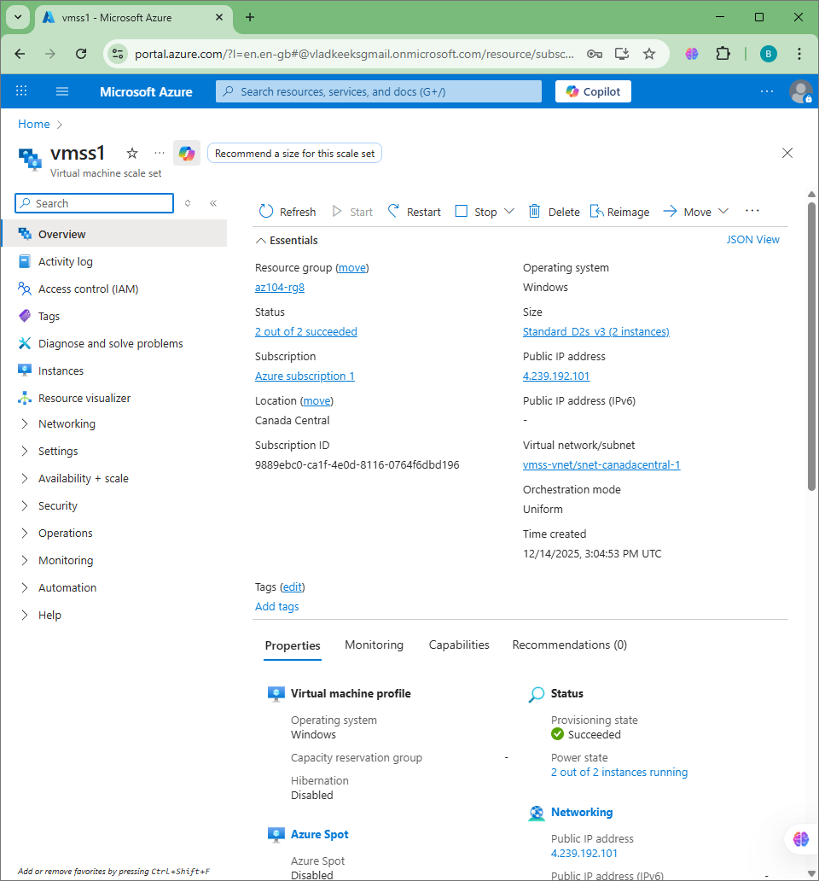

Task 4: Scale Azure Virtual Machine Scale Sets
In this task, you scale the virtual machine scale set using a custom scale rule.
- Select Go to resource or search for and select the vmss1 scale set.
- Choose Availability + Scale from the left side menu, then choose Scaling.
there is error idk why
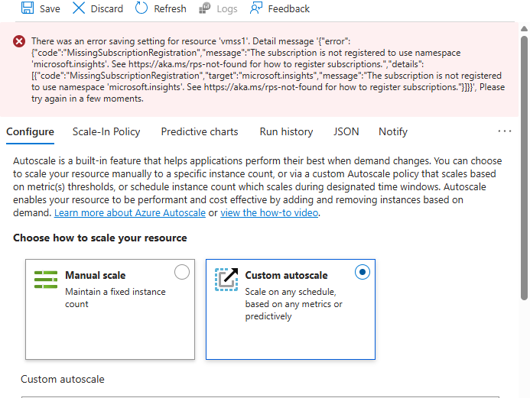

Task 5: Create a virtual machine using Azure PowerShell (option 1)
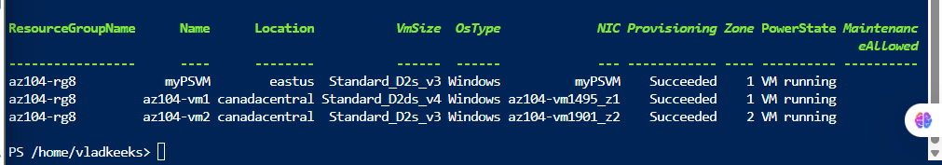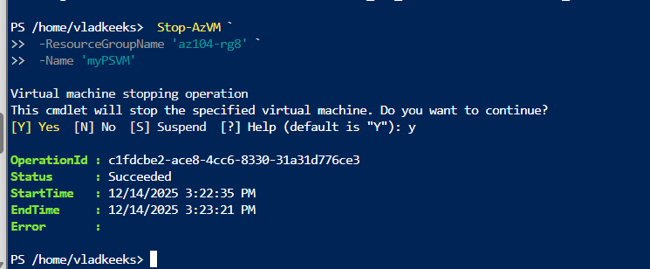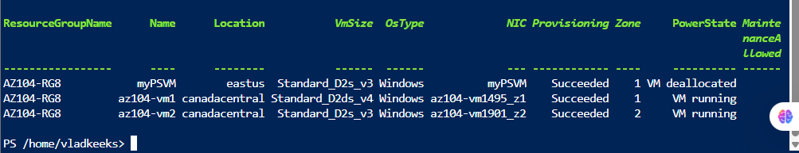

overall

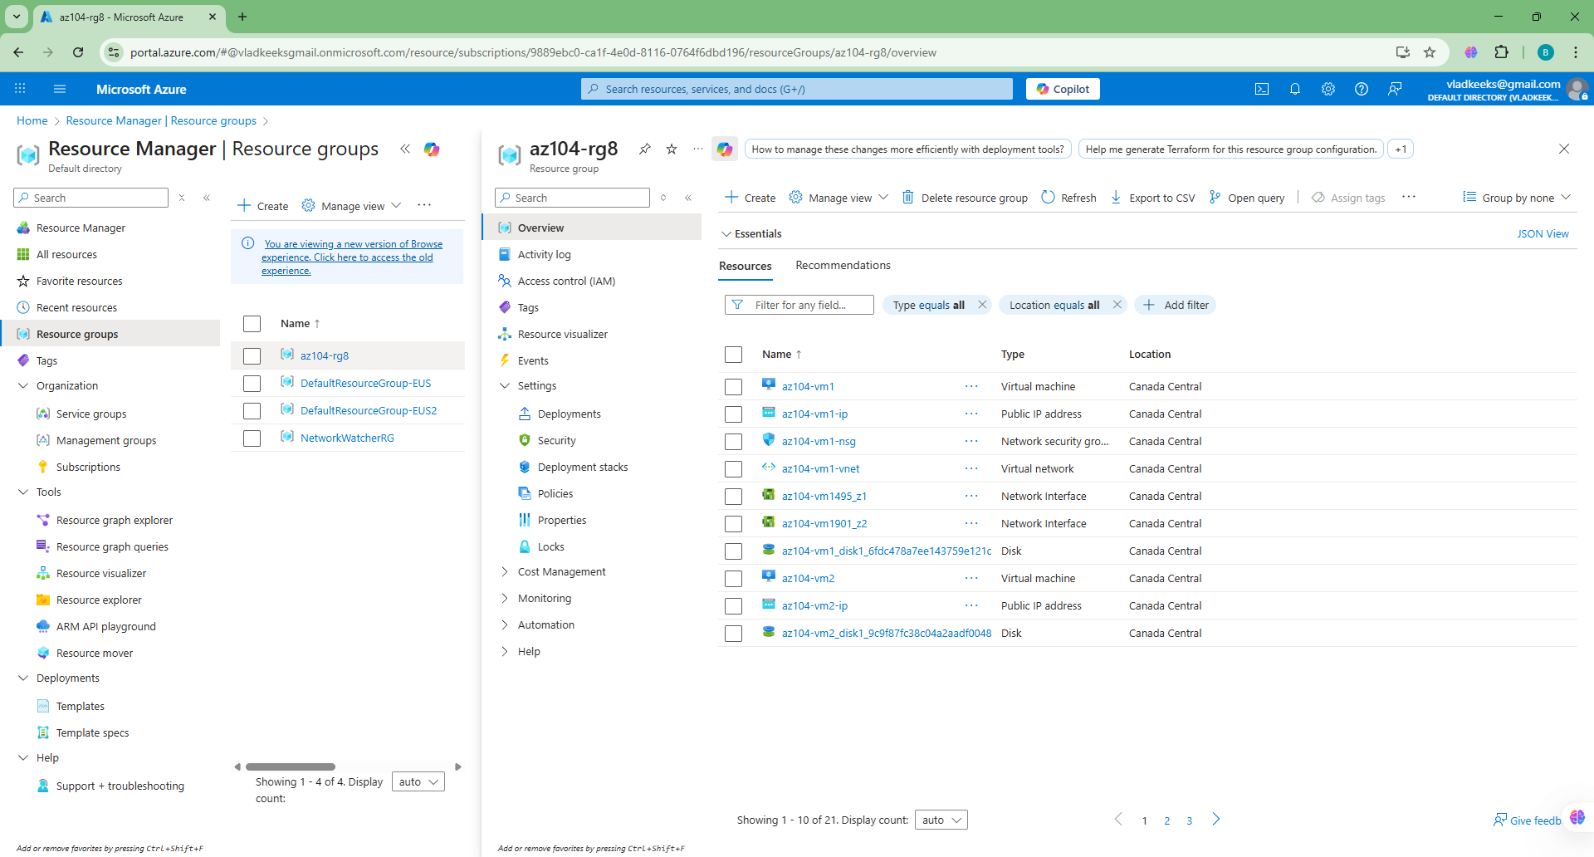

costs

